1. The entire system in one picture
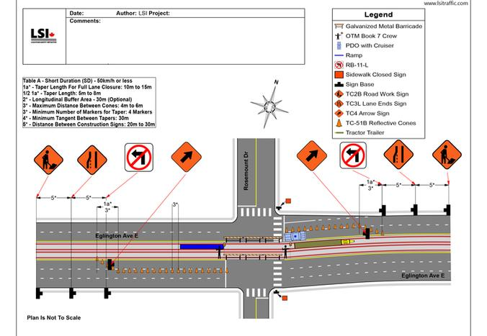
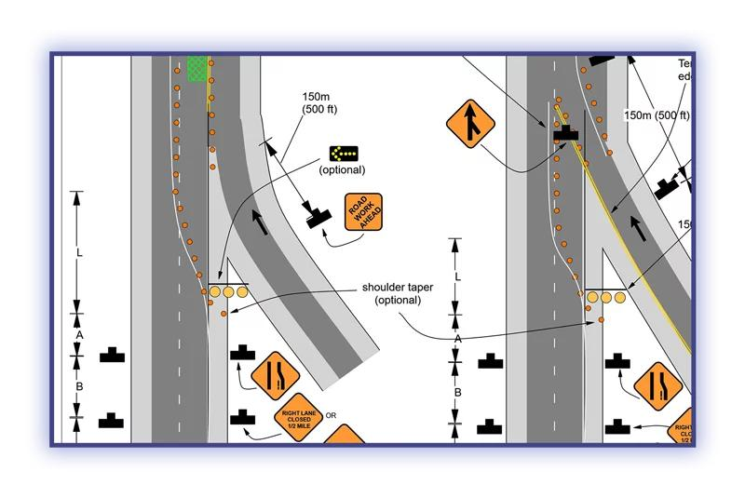
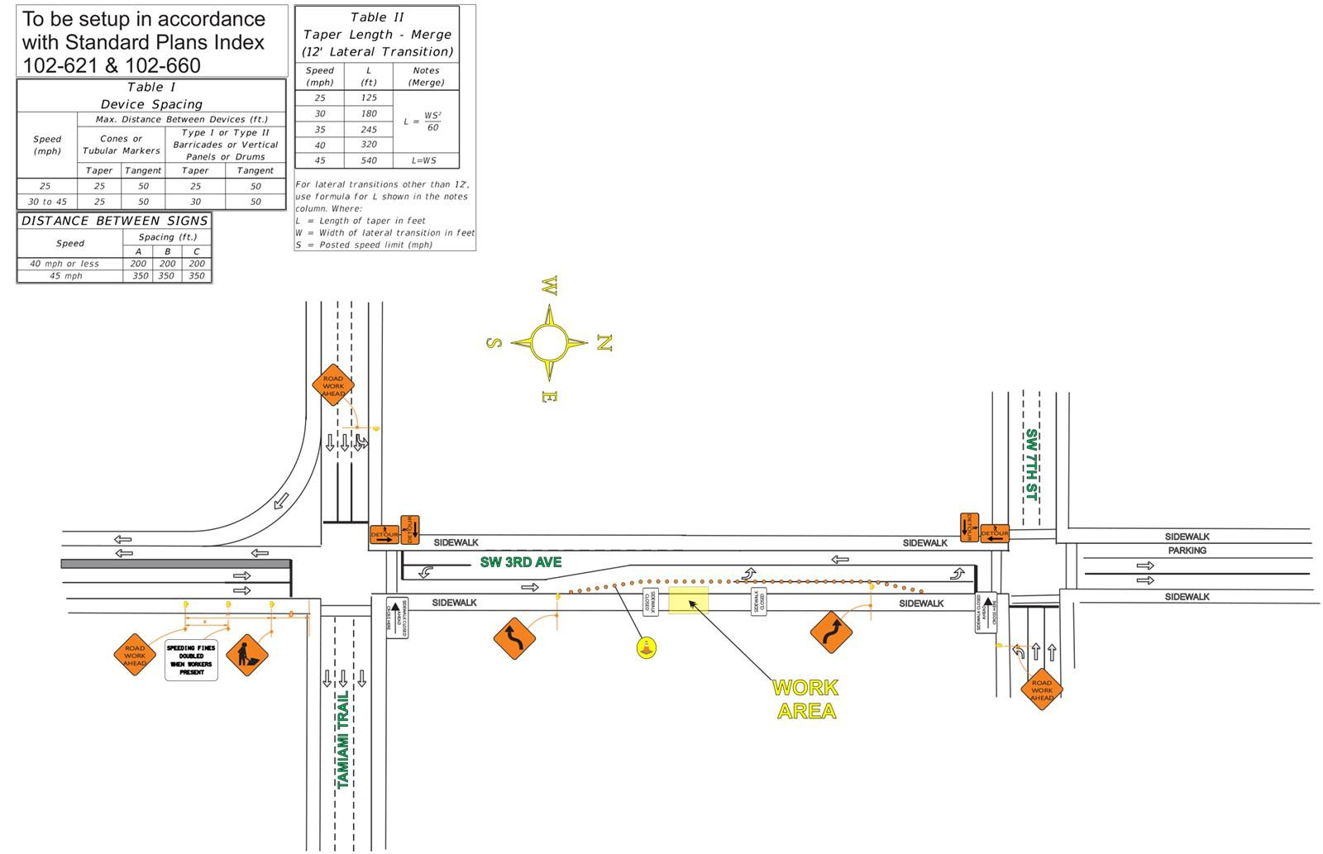
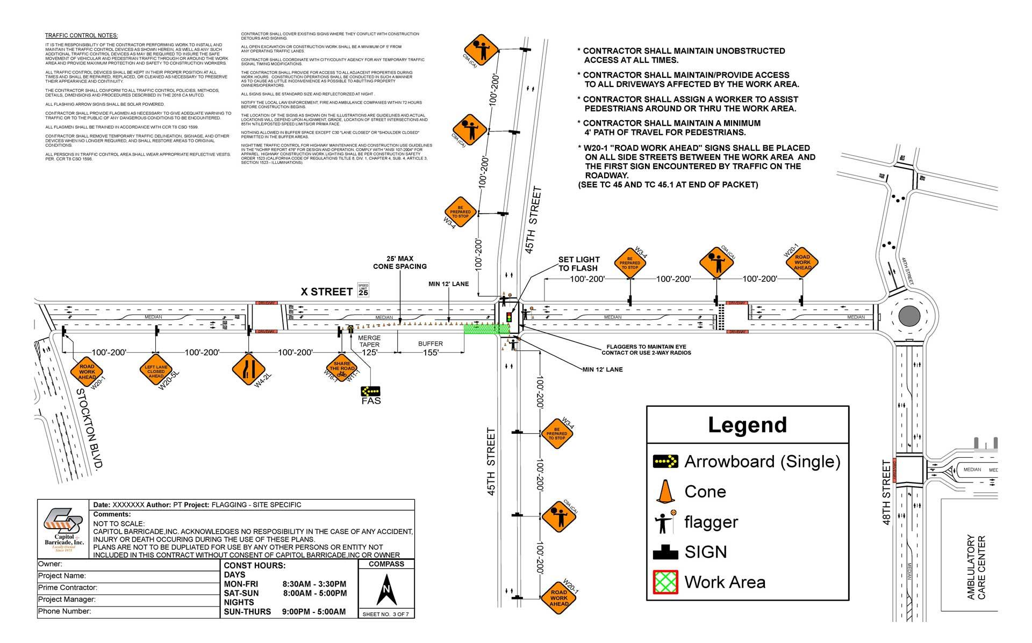
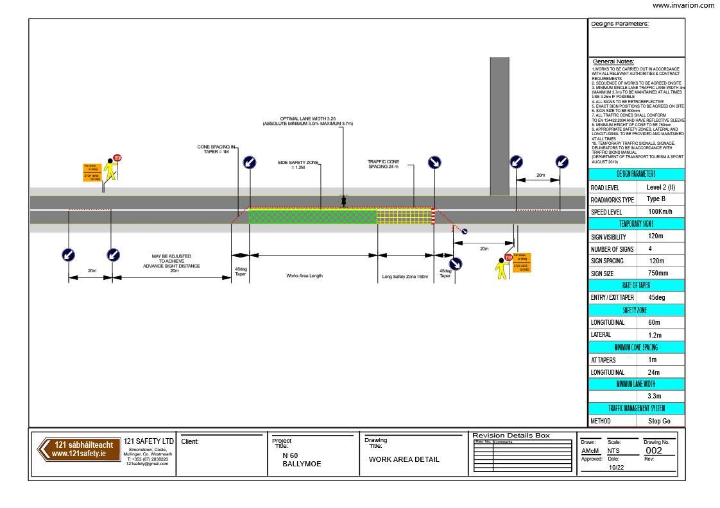

Imagine a client says:
"We need to replace a utility pole on this road tomorrow night. Here are the coordinates and a satellite image. Create the traffic-control drawing."
Your system does:
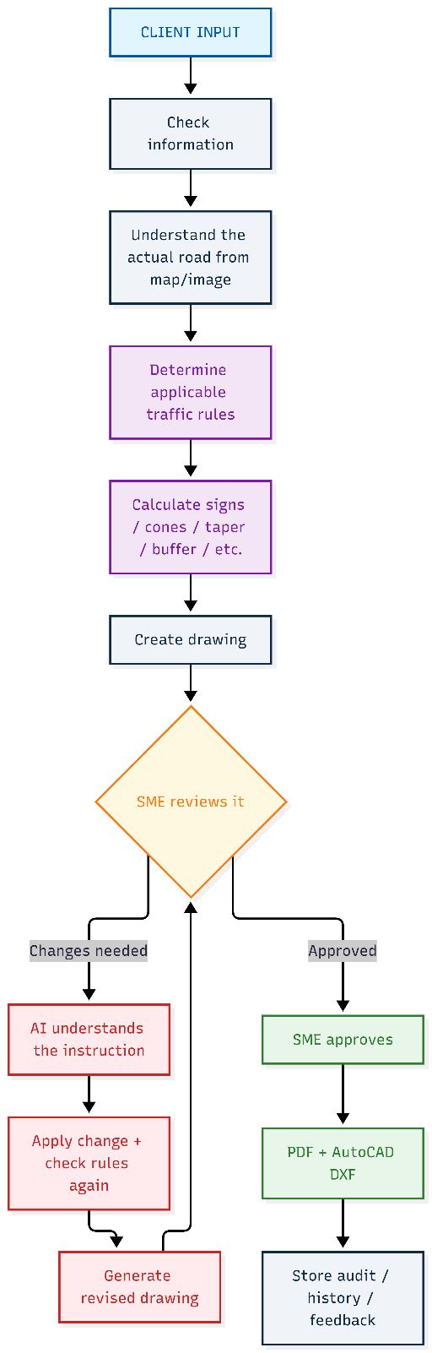
The diagram divides this into 6 major stages.

PART 0 — INPUTS
This is simply:
What information does the system receive?
There are three major inputs.
A. Project form
The client/user provides things like:
- Location
- Work scope
- Type of work
- Duration
- Day/night
- Jurisdiction
For example:
Location: Main Street & 5th Avenue
Work: Utility pole replacement
Duration: 6 hours
Time: Night
Jurisdiction: California
This is important because traffic-control requirements depend heavily on where and what work is happening.

B. KML / KMZ coordinates
The user can provide: Start point and End point
For example:
Start:
19.123456, 72.123456

End:
19.124000, 72.124100
The system uses this to understand:
"Exactly where on Earth is this work happening?"
This is the geospatial reference.
KML/KMZ is particularly useful because it gives geographic coordinates and potentially the geometry of the work area.

C. Aerial imagery / screenshot
The user can provide:
- Google Earth screenshot
- Satellite image
- Aerial photograph
- Other approved imagery
The AI/vision system can then look at it and determine things such as:
- Road
- Lane
- Shoulder
- Sidewalk
- Driveway
- Pole
- Crosswalk
- Intersection
- etc.

PART 1 — INTAKE & ELIGIBILITY
This stage answers:
"Do we have enough information, and is this project suitable for automatic processing?"
This is an important safety gate.

Step 1 — Validate inputs
The system checks:
Are mandatory fields present?
Is the KML/KMZ valid?
Can the coordinates be read?
Is the image available?
Are the files readable?
For example:
Location ✓
Work type ✓
Duration ✓
Day/night ✓
Jurisdiction ✓
KML ✓
Image ✓
If something is missing:
Missing jurisdiction
the system flags it rather than blindly continuing.

Step 2 — LLM normalizes the information
This is where the LLM is useful.
People may type things in different ways:
"pole replacement"
"replace existing pole"
"utility pole work"
"change pole"
The LLM converts that into a standard structured format.
For example:
{
"work_type": "utility_pole_replacement",
"duration_hours": 6,
"shift": "night",
"jurisdiction": "CA"
}
The diagram calls this:
LLM normalizes free text → strict JSON schema
The important point is that the LLM isn't deciding traffic rules here.
It's mainly converting messy human language into clean machine-readable information.

Step 3 — Georeference & scale
This is extremely important for your project.
The system needs to know:
How many real-world feet does one pixel represent?
For example:
Image width = 2000 pixels
Real road width = 40 feet
Then approximately: 40 / 2000 = 0.02 feet/pixel
Georeferencing: “Where exactly is each pixel/location on Earth?”
Scale: “How much real-world distance does a pixel represent?”

┌─────────────────────────────┐
│ │
│ Road │
│ ═══════════════════ │
│ ═══════════════════ │
│ ● Pole │
│ │
└─────────────────────────────┘
The computer initially only sees pixels.
For example:
Pole = pixel (1260, 740)
Road edge = pixel (400, 500)
Those are image coordinates.
They don't mean anything in feet

Why do we need real-world scale?
Suppose the rule says: “Place a sign 350 ft upstream of the work area.”
Your image doesn't understand “350 ft.”
It understands:
- 350 pixels
- 500 pixels
- 1000 pixels
So we need a conversion: PIXELS ←→ REAL WORLD DISTANCE
For example:
1 pixel = 0.25 ft
350 ft × 1/0.25 = 1,400 pixels
Therefore, the program knows: Move 1,400 pixels from the work location to place the sign.

But your actual system could obtain scale from:
Method A — KML/KMZ coordinates
If coordinates correspond to known locations in the image, the system can calculate the geographic scale.
Those coordinates are normally latitude/longitude, so you already have a real-world geographic reference.
Instead of saying: "400 pixels represents 100 ft"
you establish: "This pixel corresponds to this latitude/longitude."
KML coordinate
↓
Real-world position
↓
Match to same location in image
↓
Pixel position
↓
Georeferencing transformation

Method B — 2-point calibration
The user identifies two points.
For example:
Point A -------- Point B

Image distance = 500 pixels
Real distance = 100 feet
Therefore:
feet/pixel = 100 / 500
= 0.2 ft/pixel
This becomes the basis for placing:
- cones
- signs
- taper
- buffer
- work area
- arrows
- offsets
at the correct physical distances.

Step 4 — Eligibility gate
This is basically a traffic light for automation.
The diagram says:
Eligibility gate — low-complexity
Examples include:
- roadside pole work
- no ramp
- roundabout?
- manhole?
- multi-lane?
The system decides:
"Is this simple enough for the automated workflow?"
If NO
It goes to:
Manual drafting — AutoCAD/SME team
Meaning:
Complex project
↓
Don't let AI automatically design it
↓
Human drafting team handles it
That's a very important architectural decision.
You are not trying to automate every possible traffic-control project.
You're defining an automation boundary.
If YES
Continue to Part 2.

PART 2 — SITE UNDERSTANDING
This is where the system actually asks:
"What does this road look like?"
This is the main AI/vision portion.
There are two major sources of information.

2A — GIS / map data
The system obtains information from sources such as:
- OSM
- Overture
- DOT inventory
And extracts things like:
- Lane count
- Road class
- Direction
- Speed
For example:
Road: 2 lanes
Direction: East-West
Speed: 45 mph
Road class: Arterial

This is structured geographic information.

2B — Vision models
Then a vision model looks at the actual aerial imagery.
It can perform:
Segmentation
Identify areas:
- Road
- Lane
- Shoulder
- Sidewalk
Detection
Find individual objects:
- Driveway
- Crosswalk
- Pole
So you might get:
SIDEWALK
────────────────────────────
│
│ POLE
│
═══════╪════════════════════
Lane 1 →
Lane 2 →
════════════════════════════
The vision model might say:
Pole: 94% confidence
Road boundary: 97%
Sidewalk: 89%
Crosswalk: 82%

2C — Fusion + confidence scoring
This is one of the most important parts of the architecture.
You don't blindly trust either:
GIS
or
AI vision.
Instead you compare them.
For example:
GIS says:
2 lanes
Vision says:
2 lanes
Good.
But suppose:
GIS says:
2 lanes
Vision says:
3 lanes
Now you have a disagreement.
The diagram explicitly says:
GIS vs vision disagreements flagged
This is excellent because it prevents the system from silently making a potentially dangerous assumption.

2D — Is confidence high enough?
The system asks:
"Do we trust our understanding of the site?"
YES
Continue automatically.
NO
Ask the human.
For example:
AI:
"I found a possible driveway here,
but confidence is only 62%.

Please confirm."
The user then confirms/corrects it.

2E — Create the Site Model
Once the information is sufficiently reliable, the system creates a:
Versioned Site Model
Containing things like:
Centerline
Lanes
Work location
Road geometry
Objects
Relevant features
Think of it as the computer's structured understanding of the site.
Instead of merely having a picture:
[IMAGE]
you now have:
{
"road": {...},
"lanes": [...],
"centerline": {...},
"work_location": {...},
"poles": [...],
"sidewalk": {...}
}
This becomes the input to Part 3.

PART 3 — RULES & LAYOUT
This is probably the most important architectural principle in your diagram.
The title explicitly says:
RULES & LAYOUT — deterministic, no AI
Meaning:
AI does NOT decide where cones/signs should go.
Instead, the system uses predefined traffic-control rules and mathematical calculations.

Step 1 — Select jurisdiction rule pack
First:
"Which traffic rules apply?"
For example:
MUTCD baseline
+
State rules
+
Local rules
So:
Project location
↓
Jurisdiction
↓
Correct rule pack
This prevents using the wrong state's requirements.

Step 2 — Select standard pattern
Now the system identifies the appropriate standard work-zone configuration.
For example:
Roadside pole work
could correspond to an approved standard pattern.
Instead of inventing a layout, the system says:
Work type
↓
Approved pattern #X

Step 3 — Calculate everything from tables
This is where deterministic engineering calculations happen.
For example:
Sign sequence
Which signs appear and in what order?
Sign 1
Sign 2
Sign 3
Taper
How long should the taper be?
Buffer
How much distance should separate traffic from workers?
Cone spacing
How far apart should cones be?
Worker protection
What protective measures are required?
The important idea is:
These values come from approved rules/tables, not from an LLM guessing.

Step 4 — Place devices
Now the system puts the objects onto the site.
For example:
S1 = Sign 1
S2 = Sign 2
S3 = Sign 3

C1 = Cone 1
C2 = Cone 2
C3 = Cone 3

V1 = Vehicle/device 1
The diagram says:
Place devices on centerline offset to work side
So the system understands the road geometry and places the traffic-control devices relative to the actual work area.

Step 5 — Repeat approved pattern
Suppose there are multiple poles:
Pole 1
Pole 2
Pole 3
Pole 4
The system doesn't manually reinvent the plan for every pole.
It applies the approved pattern across:
poles / corridor segments
This makes the system scalable.

Step 6 — Validate against every rule
Before drawing the final output, the system checks:
✓ Sign sequence
✓ Taper
✓ Buffer
✓ Cone spacing
✓ Work-zone protection
✓ Required devices
✓ Required dimensions
✓ Jurisdiction rules
It also generates:
Issue list + rule citations
For example:
ISSUE:
Cone spacing exceeds permitted distance.

RULE:
Applicable rule XYZ.

REQUIRED:
Reduce spacing to X ft.
This is much safer than:
"AI thinks this looks okay."

PART 4 — DRAW & EXPORT
Now the system has the correct logical plan.
The next question is:
How do we turn that into an actual engineering drawing?

Step 1 — Canonical plan model
The diagram calls this:
Canonical plan model (JSON) — single source of truth
This is a very good architectural concept.
Instead of:
AI → directly draws PDF
AI → directly draws AutoCAD
you have:
CANONICAL JSON
│
┌────────┴────────┐
↓ ↓
PDF DXF/AutoCAD
For example:
{
"road": {...},
"work_area": {...},
"signs": [
{"id":"S1", "x":100, "y":200},
{"id":"S2", "x":150, "y":200}
],
"cones": [...]
}
This JSON becomes the single source of truth.
That means PDF and AutoCAD should represent the same underlying plan.

Step 2 — Render on imagery
Now the system takes:
Site imagery
+
Plan model
and creates the visual drawing.
It adds:
- symbols
- IDs
- dimensions
- legend
- title block
- north arrow
So now you get something that looks like an actual TCP drawing.

Step 3 — Stamp it as DRAFT
The system adds:
DRAFT
plus:
- rule version
- model versions
This is important because someone needs to know:
"Which version of the rules and AI produced this drawing?"

Step 4 — Export
Two major outputs:
PDF
For:
- viewing
- review
- submission
DXF
For:
AutoCAD
The diagram mentions:
ADR-010
and:
layers + blocks for AutoCAD
So the DXF isn't simply a flattened picture.
It should contain structured CAD objects/layers that a designer can continue editing.

PART 5 — SME REVIEW LOOP
Now comes the human-in-the-loop.
SME means:
Subject Matter Expert
In this case, someone experienced in traffic-control/engineering/drafting.
The system gives the SME the draft.

Step 1 — SME reviews
The diagram says:
SME reviews draft — every item has a visible ID
This is extremely important.
Instead of saying:
"Move that cone."
The SME can say:
"Move C3 10 feet."
Because every object has an ID.
Example:
S1
S2
S3

C1
C2
C3
C4

Step 2 — Accept as-is?
The SME has two choices.
YES
The plan goes toward approval.
NO
The SME gives instructions.
For example:
"Move S3 to 250 ft."
or:
"Remove C8."
or:
"Increase the taper."

Step 3 — LLM converts instruction into structured change
This is another important distinction.
The SME might write natural language:
"Move S3 to 250 ft on the right."
The LLM converts that into something structured:
{
"action": "move",
"object": "S3",
"distance": 250,
"side": "right"
}
The LLM is interpreting the instruction, not inventing the engineering rule.

Step 4 — Echo back for confirmation
The system says:
"I understood: move S3 to 250 ft."
This is a safety mechanism.
The human can catch misunderstandings before the change is applied.

Step 5 — Rules check
This is extremely important.
Suppose the SME says:
"Move S3 here."
The system doesn't simply obey.
It checks:
Does this violate a rule?
If yes:
CONFLICT

Requested location violates Rule X.

Nearest compliant option:
250 ft → 280 ft
So the system is essentially saying:
"I understand what you want, but that exact change isn't compliant. Here's the closest compliant alternative."
The diagram explicitly says:
conflict → name the rule + offer nearest compliant option

Step 6 — Regenerate
Once the change is accepted:
Old plan
↓
Change
↓
Rules validation
↓
New plan
The diagram calls it:
Regenerate as vN+1
Meaning:
Version 1
↓
Version 2
↓
Version 3
↓
...
And it expects this regeneration to happen in seconds.

The LOOP is the key
This is probably the most important concept in the entire diagram:
Generate
↓
SME reviews
↓
Change required?
↓
YES
↓
LLM understands instruction
↓
Structured change
↓
Confirm
↓
Rule check
↓
Regenerate
↓
SME reviews again
↓
...
It keeps looping until the SME accepts the plan.

PART 6 — APPROVAL, AUDIT & LEARNING
Once the SME finally accepts the plan, the system records the approval.

6A — SME approval recorded
The system stores:
SME name
Date
Rule version
So later you know:
Who approved this?
When?
Under which rule version?

6B — Downstream use
Now the plan can be used for:
Finalize in AutoCAD → permit submission
So the output isn't merely an AI picture.
It's intended to become a real production deliverable.

6C — Immutable audit log
The system stores:
Inputs
Versions
Decisions
And importantly:
Immutable
Meaning the history should not casually be changed.
For example:
10:32 — Project received
10:35 — Site model v1
10:37 — Draft v1
10:45 — SME requested S3 move
10:46 — Draft v2
10:52 — SME approved
This is valuable for traceability.

6D — Permit feedback
The system also captures:
Permit feedback
such as:
Revision requested
Rejected
Accepted
This becomes valuable historical data.

6E — Metrics
The system measures things such as:
Drafting time
How long did it take to produce the first draft?
Rework rounds
How many times did the SME ask for changes?
Example:
Draft v1
↓
SME changes
Draft v2
↓
SME changes
Draft v3
↓
Approved
That's:
2 rework rounds.
First-pass acceptance
Did the SME accept the first draft?
Rejection rate
How frequently are plans rejected?
These metrics tell you whether the automation is actually improving the process.

6F — Corrections become potential rule improvements
The final box says essentially:
Corrections analysed → propose new rule/test → SME approves wording
This is important.
Suppose over 500 projects you discover:
The same correction occurs 100 times.
The system can identify that pattern.
But it does not automatically rewrite the traffic rules.
Instead:
Historical corrections
↓
Analyse pattern
↓
Propose rule/test improvement
↓
SME reviews
↓
SME approves wording
↓
New rule/test
That's a much safer approach.

Now let's connect the entire thing with one REAL example
Suppose your client gives you:
"Replace a roadside utility pole on a 2-lane road. Work will happen at night. Here is the KML and aerial image."

STEP 1 — Client input
Project:
Pole replacement

Location:
Coordinates

Time:
Night

Duration:
4 hours

Jurisdiction:
X

KML:
✓

Aerial image:
✓
↓
STEP 2 — Intake
System validates everything.
↓
LLM converts:
"replace pole at night for 4 hours"
into:
{
"work_type": "pole_replacement",
"shift": "night",
"duration": 4
}
↓
STEP 3 — Geospatial calculation
System determines:
Where is the work?

What is the image scale?

What is feet/pixel?
↓
STEP 4 — Eligibility
System says:
Simple roadside work
No ramp
No complicated intersection

→ Eligible
↓
STEP 5 — AI understands road
GIS:
2 lanes
40 mph
Vision:
2 lanes
pole detected
sidewalk detected
driveway detected
Fusion:
Confidence = high
↓
Create:
SITE MODEL v1
↓
STEP 6 — Rules engine
Determine:
Jurisdiction rules
+
pole-work pattern
+
required signs
+
taper
+
buffer
+
cone spacing
↓
Calculate actual positions.
↓
STEP 7 — Generate drawing
Create:
S1
S2
S3

C1
C2
C3
...
with dimensions and legend.
↓
Export:
TCP_DRAFT_V1.pdf
TCP_DRAFT_V1.dxf
↓
STEP 8 — SME reviews
SME says:
"Move S3 farther upstream."
↓
LLM converts:
{
"action": "move",
"object": "S3",
"direction": "upstream",
"distance": "..."
}
↓
System says:
"I understood: move S3 to X."
SME confirms.
↓
Rules engine checks.
✓ compliant
↓
Generate:
TCP_DRAFT_V2
↓
SME reviews again.
Accept?
YES
↓
STEP 9 — Approval
Store:
Approved by: SME
Date: ...
Rule version: ...
Plan version: V2
↓
STEP 10 — Final outputs
PDF
DXF
Audit record
Permit package

The most important architectural idea
Your diagram actually separates the system into three very different types of intelligence.
1. LLM / AI
Used for things like:
Understand human language
Normalize inputs
Understand SME instructions
Interpret imagery
Detect/segment site features
2. Deterministic engineering/rules engine
Used for:
Traffic rules
Distances
Taper
Buffer
Cone spacing
Sign sequence
Compliance validation
Geometry calculations
3. Human SME
Used for:
Confirm site interpretation
Review final design
Give corrections
Approve
Handle complex cases
Approve rule changes
That gives you:
AI
┌──────┴──────┐
↓ ↓
Understand Interpret
│ │
└──────┬──────┘
↓
RULES ENGINE
deterministic
↓
DRAWING
↓
SME
↓
APPROVAL

Why the "NO AI" in Part 3 is important
If someone asks:
"Why don't we just ask GPT to design the whole traffic plan?"
The answer is:
Because the system should not rely on an LLM to invent safety-critical traffic-control decisions.
Instead:
AI understands
↓
Rules engine calculates
↓
Renderer draws
↓
Human approves
This creates a much stronger architecture for a production system.

And the versioning is everywhere
Your diagram is also quietly building a traceability system.
You have:
Site Model v1
Site Model v2

Plan v1
Plan v2
Plan v3

Rule Pack v1
Rule Pack v2

Model version X
Model version Y

SME approval
Audit log
So if someone asks six months later:
"Why was this sign placed here?"
you can potentially trace:
Sign S3
↓
Plan V4
↓
Rule Pack V7
↓
Site Model V3
↓
Input KML
↓
SME modification
↓
Final approval
That is a major enterprise feature, not just an AI drawing tool.

In one sentence
The whole diagram means:
Take messy client/project information and geographic data, use AI to understand the site and human instructions, use a deterministic rules engine to make compliant traffic-control decisions, automatically produce PDF/AutoCAD drawings, have an SME verify everything, and maintain complete versioning, audit history and feedback for continuous improvement.
And the fundamental flow is:
0. INPUT
↓
1. VALIDATE + ELIGIBILITY
↓
2. AI UNDERSTANDS SITE
↓
3. RULE ENGINE DESIGNS TRAFFIC CONTROL
↓
4. SYSTEM DRAWS PDF/DXF
↓
5. SME REVIEWS + CORRECTS
↓
└─────── regenerate ───────┐
│
↓
SME approves
↓
6. APPROVAL + AUDIT + LEARNING
The strongest part of this architecture is that AI is deliberately NOT the final authority for the traffic-control rules. It is used where AI is good—language, image/site understanding and interpreting human instructions—while deterministic calculations and human approval control the safety-critical portion.

